BDSE Part 2

Quirijn Langedijk

500782499

quirijn.langedijk@hva.nl

email@quirijnlangedijk.nl

Inhoud

Summary 3

Introduction 4

Background 4

Methods 6

Spark Logistic Regression 6

Spark Support Vector Machine 7

Dask vs Pandas 7

Visualisation 9

Results 11

Spark Logistic Regression 11

Spark Support Vector Machine 11

Dask vs Pandas 11

Visualisation 11

Conclusion 13

Reference list 13

# Summary

I used Spark to create two different models, Logistic Regression and Support Vector Machine. To create the best possible model, I used cross validation with both models. The ‘best’ models I created had an accuracy of 94.08% (LR) and 93.91% (SVM) and ROC-AUC of 98.07% (LR) and 97.86% (SVM)

I also checked if the accuracy went up if I increased the size of the dataset. In this case, it improved with both models. In the case of Logistic Regression the accuracy went up with 6.18% (1000 vs 100000 rows), the ROC-AUC went up with 4.62, while the time to train went up with 57 seconds. With Support Vector Machine, the differences between the biggest and smallest dataset were +6.81% accuracy, +4.04% ROC-AUC and an increase of 11m54s. Because of the shorter training time, and higher accuracy, I think Logistic Regression is the better model in this case.

I also did some small tests to compare the memory usage of Dask vs Pandas. In my case, Dask could handle way more data than Pandas, although loading data took a bit longer versus Pandas.

I also visualized the dataset that I used to train both models. The greener the dot, the higher the rating, the bigger the dot, the more ratings there are. It’s also possible to filter the data on the average rating.

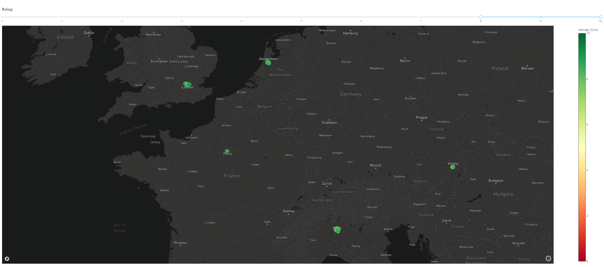

# Introduction

With this assignment, it was our task to do a couple of things; Create a visualization of a dataset containing around 600.000 hotel reviews, use Spark to create a machine learning algorithm to classify the reviews as positive or negative, and create a simulation on how to solve storage problems.

# Background

For this assignment, I used Spark to implement a Logistic Regression model. Where Linear Regression is able to predict a value based on an input value (for example size based on weight, infinite Y values), Logistic Regression can only predict if a value is True or False (Y between 0 and 1).

Instead of having a straight line, Logistic Regression uses a Sigmoid function to calculate probability, which is displayed as the following:

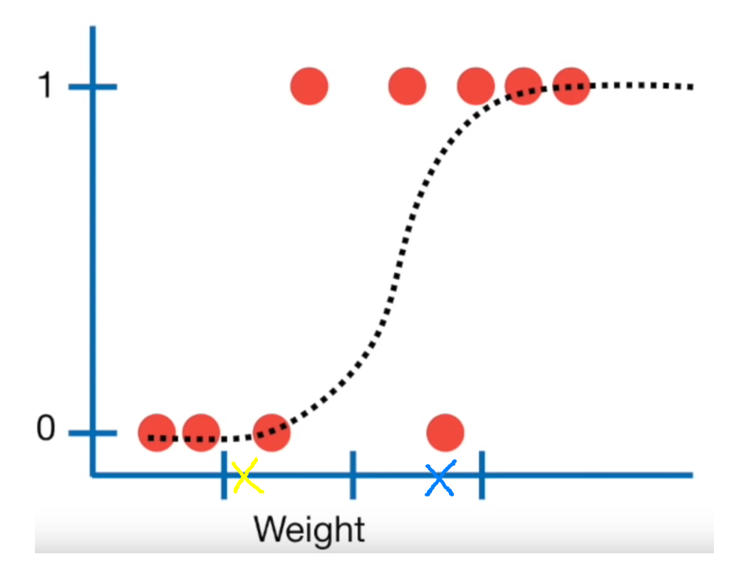

With this graph, we can predict the probability someone is obese by their weight. In the example above, if 0 is classified as not obese, and 1 as obese, there’s a big chance the blue cross is classified as obese, while the chance is lower with the yellow cross. (Starmer, 2018)

For my other model I used a Support Vector Machine, which works by plotting the points created by the TF. The algorithm will then find the line that’s the furthest away from both the positive (D+), as the negative (D-) points.

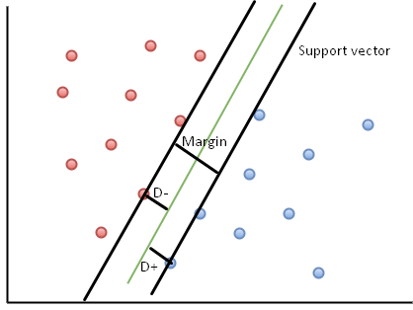

In the example below, the green line is the best hyperplane (Totta datalab, 2018). The red lines are not the ideal lines, since the D- and D+ distances aren’t the highest they could be. If a wrong hyperplane is chosen, lots of misclassifications will happen, since the model uses the position of a point relative to the line to classify an input.

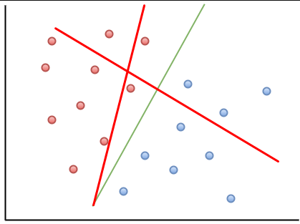

# Methods

## Spark Logistic Regression

To classify the reviews as positive or negative, I used a Spark Pipeline with Logistic Regression. We first create a SparkSession to retrieve data from the MongoDB:

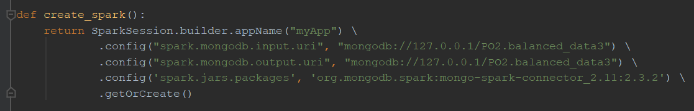

Then load the data, drop the _id column (since it’s useless for classification), and divide the SparkDF into a train and test set:

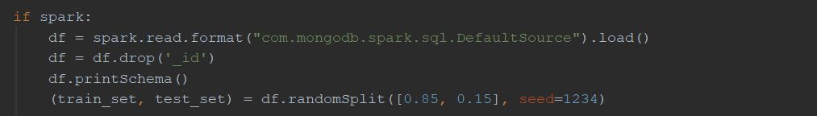

Were then ready to build the Pipeline, since were processing text, we will have to create values for each word before we can use them in Logistic Regression. This is done by tokenizing and hashing the words.

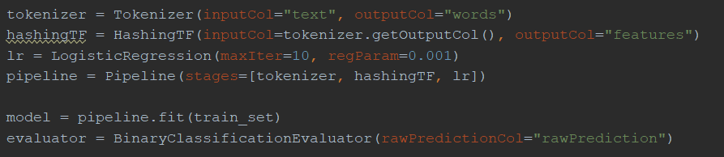

To optimize our model, we use cross validation, this means Spark will try out different combinations of the given parameters, and picks out the ones that fit the data the best:

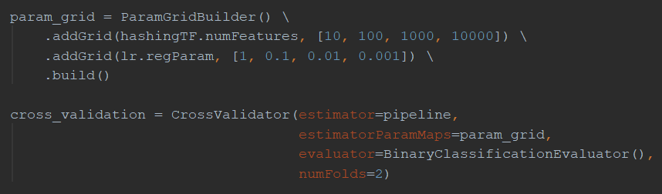

Were then ready to fit the data, and test the model afterwards:

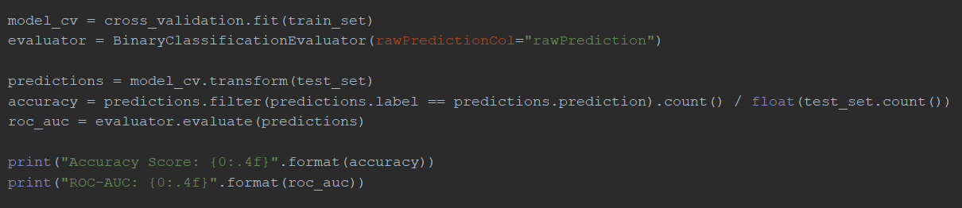

In the case of these parameters the Accuracy was 92.4%, ROC-AUC 96.7%, and train time 39 seconds.

## Spark Support Vector Machine

The way I trained by SVM was similar to the way I trained Logistic Regression, except for the line where I create a LogisticRegression object, I created a SupportVectorMachine object:

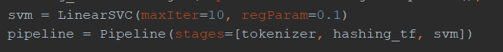

## Dask vs Pandas

To test the RAM usage of Pandas and Dask, I first took the time and current memory usage:

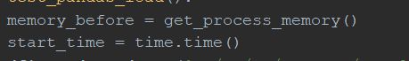

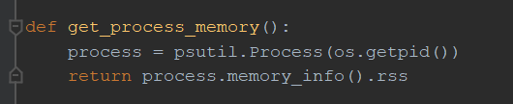

Then I read the dataframe and Dask dataframe, and concat them 5/10 times to increase the size of the (Dask) dataframe:

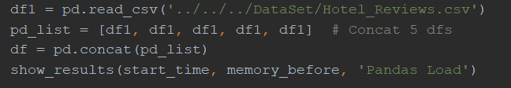



After that, I measured the time/RAM usage to filter the dataframes:

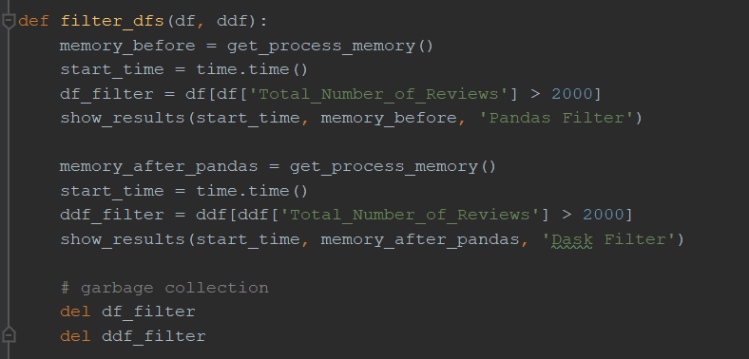

As well as drop the duplicates and get the sums:

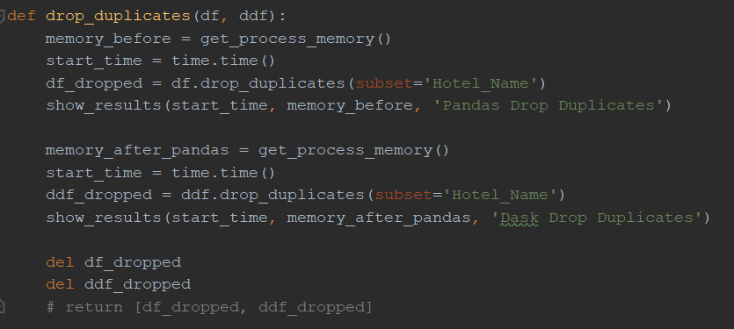

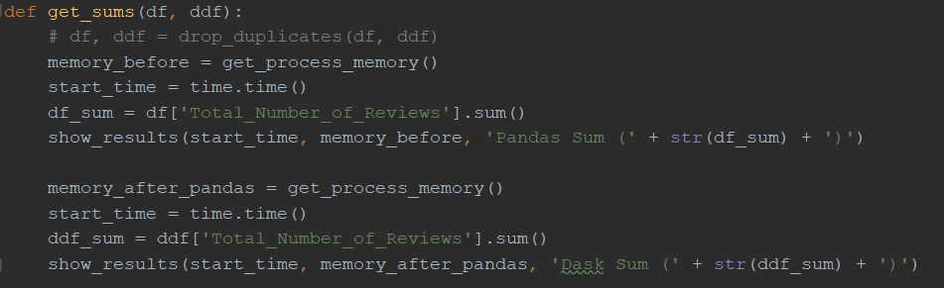

I then saved the positive/negative rows:

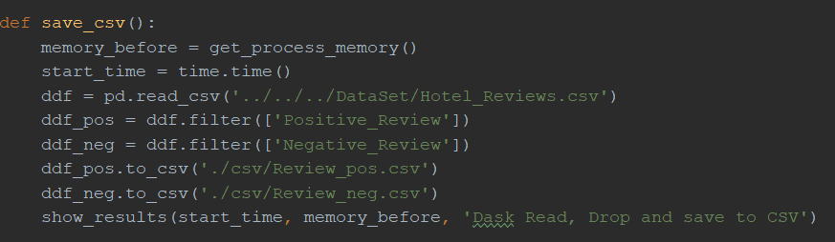

## Visualisation

I created a map using a Plotly Express Scatterbox map. In this map each hotel is a different dot. As can be seen in the screenshots in the Results section, I also have a filter where you’re able to give a minimum/maximum rating. To get the correct data, I created a query that only returns the data you requested.

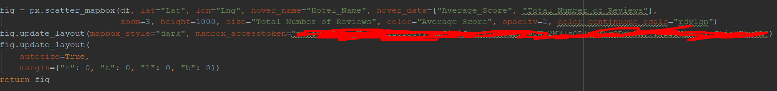

This query also makes sure only one row is returned for each hotel, instead of one row per review.

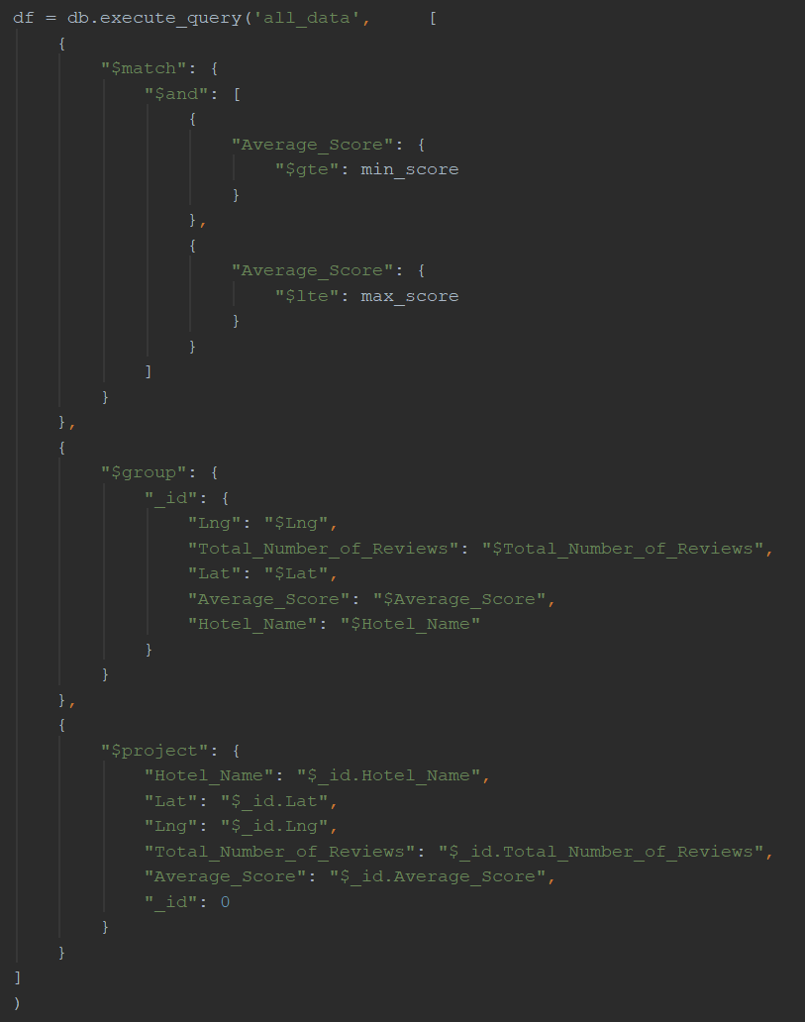

Whenever the rating slider is changed, the following callback gets executed, updating the map with the new data:

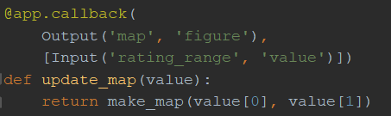

To create the table with reviews, I have another callback that retrieves data about the hotel you clicked on, and displays it in a table:



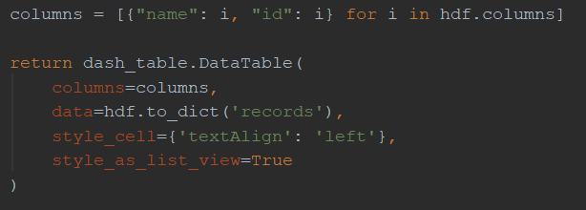

# Results

## Spark Logistic Regression

|  |  |  |  |
| --- | --- | --- | --- |
| Number of rows | Accuracy Score | ROC-AUC | Train time |
| 1000 | 87.90% | 93.45% | 00:00:57 |
| 5000 | 90.58% | 95.55% | 00:01:04 |
| 10000 | 91.84% | 96.24% | 00:01:00 |
| 50000 | 93.57% | 98.05% | 00:01:28 |
| 100000 | 94.08% | 98.07% | 00:01:54 |

## Spark Support Vector Machine

|  |  |  |  |
| --- | --- | --- | --- |
| Number of rows | Accuracy Score | ROC-AUC | Train time |
| 1000 | 87.10% | 93.82% | 00:01:01 |
| 5000 | 91.11% | 95.96% | 00:01:30 |
| 10000 | 92.98% | 97.21% | 00:02:44 |
| 50000 | 93.73% | 93.73% | 00:07:31 |
| 100000 | 93.91% | 97.86% | 00:12:55 |

## Dask vs Pandas

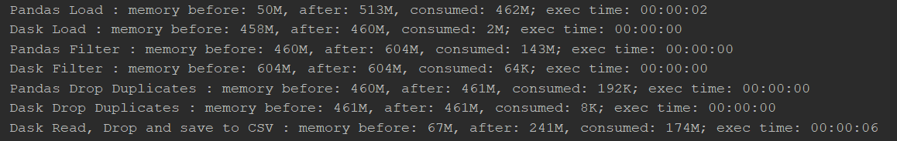

As you can see, the ram usage is way lower with Dask than Pandas, Dask had no problem dealing with dataframes of 7+ million rows, whereas Pandas already maxed out at half of that.

## Visualisation

The visualization I made looks like this:



This shows all hotels in the dataset. The greener the hotel is, the higher the average rating is, the bigger the hotel’s dot, the more reviews they have, as you can see in the example below, The Student Hotel Amsterdam has a rating of 8.7, which is why the circle is dark green, it also has one of the biggest circles in Amsterdam, because it has the most reviews.

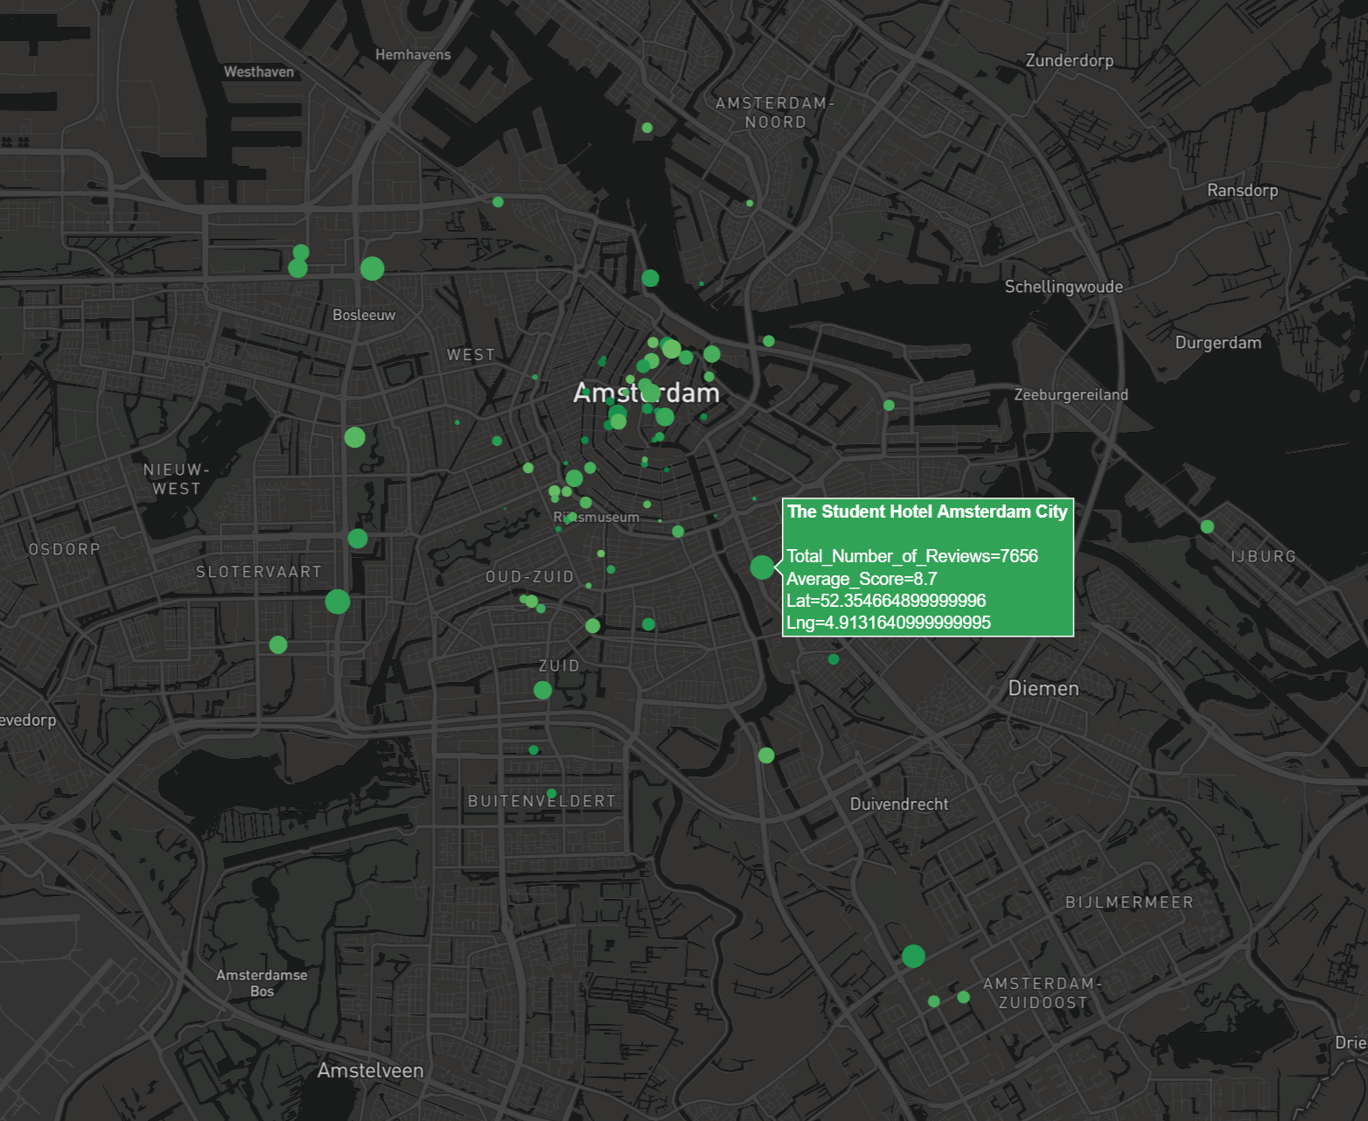

The slider ontop can be used to filter the hotels based on their average rating. There’s only 1 hotel in the dataset that has an unsatisfactory rating, which is Hotel Liberty in Milan:

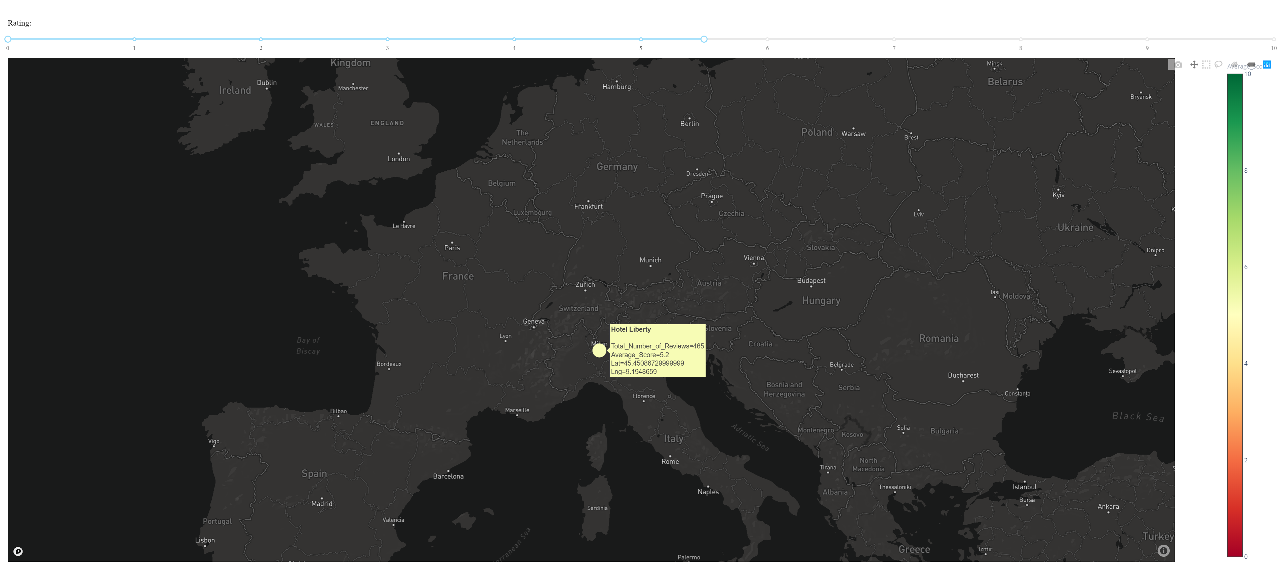

If we click on a hotel, we can see the data about it, in this case for the hotel above:

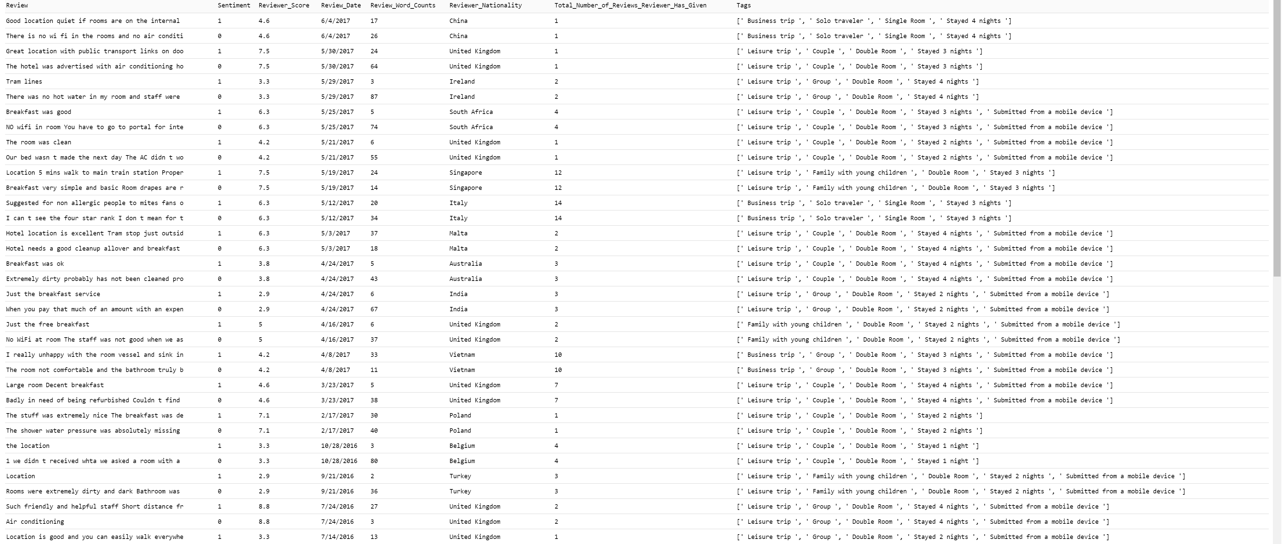

# Conclusion

If I had to choose between the two models I trained with Spark, I’d go with Logistic Regression, since when I trained it with 100k reviews, the accuracy and ROC-AUC were quite high (94.08%/98.07%), while keeping the train time very low (00:01:54). The accuracy and ROC-AUC were similar with SVM, but the train time was 8x as shorter with Logistic Regression.

# Reference list

Starmer, J. (2018, maart 5). *StatQuest: Logistic Regression*. Opgehaald van Youtube: https://youtu.be/yIYKR4sgzI8

Totta datalab. (2018, november 28). *Wat zijn support vector machines en hoe werken ze?* Opgehaald van Totta datalab: https://www.tottadatalab.nl/2018/11/28/support-vector-machines/